**Experiment – 7**

Q1) Write a program that removes all the occurrences of a specified string from a text file. For example, invoking java Practical7_1 John filename removes the string John from the specified file. Your program should read the string as an input.

Ans:

**Program:**

package Exp_7;

import java.io.*;

import java.util.Scanner;

public class First {

    public static void main(String[] args) {

        File f1 = new File("Exp_7/First.txt");

        Scanner sc = new Scanner(System.in);

        try{

            f1.createNewFile();

            // enter content in file

            FileWriter fileWriter = new FileWriter(f1);

            System.out.println("Enter content of the file: ");

            String inputString = sc.nextLine();

            fileWriter.write(inputString);

            fileWriter.close();

            System.out.println("\nEnter string to remove from file: ");

            String text = sc.nextLine();

            StringBuilder updatedContent = new StringBuilder();

            Scanner s = new Scanner(f1);

            while(s.hasNextLine()){

                String line = s.nextLine();

                if(line.contains(text)){

                    String updatedLine = line.replace(text, "");

                    updatedContent.append(updatedLine).append("\n");

                }

            }

            s.close();

            FileWriter updater = new FileWriter(f1);

            updater.write(updatedContent.toString().trim());

            updater.close();

            System.out.println("\nSuccessfully removed " + text + " from the file.");

            System.out.println("\n\nNew contents of file are: ");

            Scanner s2 = new Scanner(f1);

            while(s2.hasNextLine()){

                System.out.println(s2.nextLine());

            }

            s2.close();

        }

        catch(IOException e){

            System.out.println("Error while file handling! ");

        }

    }

}

**Output:**

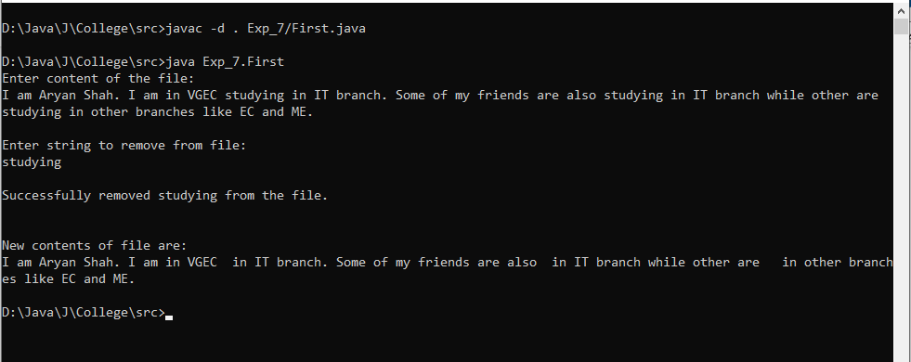

Q2) Write a program that will count the number of characters, words, and lines in a file. Words are separated by whitespace characters. The file name should be passed as a command-line argument.

Ans:

**Program:**

package Exp_7;

import java.io.*;

import java.util.Scanner;

public class Second {

    public static void main(String[] args) {

        Scanner sc = new Scanner(System.in);

        System.out.println("Enter File Name: ");

        String fileName = sc.nextLine();

        try{

            File f = new File(fileName);

            Scanner s = new Scanner(f);

            int countCharacters = 0;

            int countWords = 0;

            int countLines = 0;

            while(s.hasNextLine()){

                countLines+=1;

                String currentLine = s.nextLine();

                String[] words = currentLine.split(" ");

                countWords += words.length;

                for(String i : words){

                    String[] letters = i.split("");

                    countCharacters += letters.length;

                }

            }

            s.close();

            System.out.println("\nNumber of lines: "+countLines);

            System.out.println("Number of words: "+countWords);

            System.out.println("Number of characters: "+countCharacters);

        }

        catch(IOException e){

            e.printStackTrace();

        }

    }

}

**Output:**

Q3) Write a program to create a file named Practical7.txt if it does not exist. Write 100 integers created randomly into the file. Integers are separated by spaces in the file. Read the data back from the file and display the data in increasing order.

Ans:

**Program:**

package Exp_7;

import java.util.Scanner;

import java.util.Random;

import java.io.*;

public class Third {

    public static void main(String[] args) {

        File f = new File("Exp_7/Third.txt");

        try{

            if(!f.exists()){

                f.createNewFile();

            }

            FileWriter writer = new FileWriter(f);

            Random rand = new Random();

            for(int i=0;i<100;i++){

                int x = rand.nextInt(500);

                writer.write(x+" ");

            }

            writer.close();

            Scanner s = new Scanner(f);

            while(s.hasNextLine()){

                System.out.println(s.nextLine());

            }

            s.close();

        }

        catch(IOException e){

            System.out.println(e.getMessage());

        }

    }

}

**Output:**

